CS423 – All labs documentation  
Jevgenij Ivanov 20748055

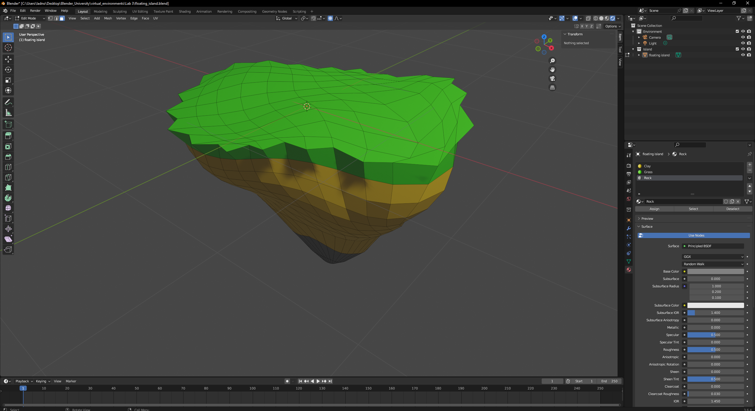  
This is how I’ve set up my floating island, screenshot of blender. Collections are organised.

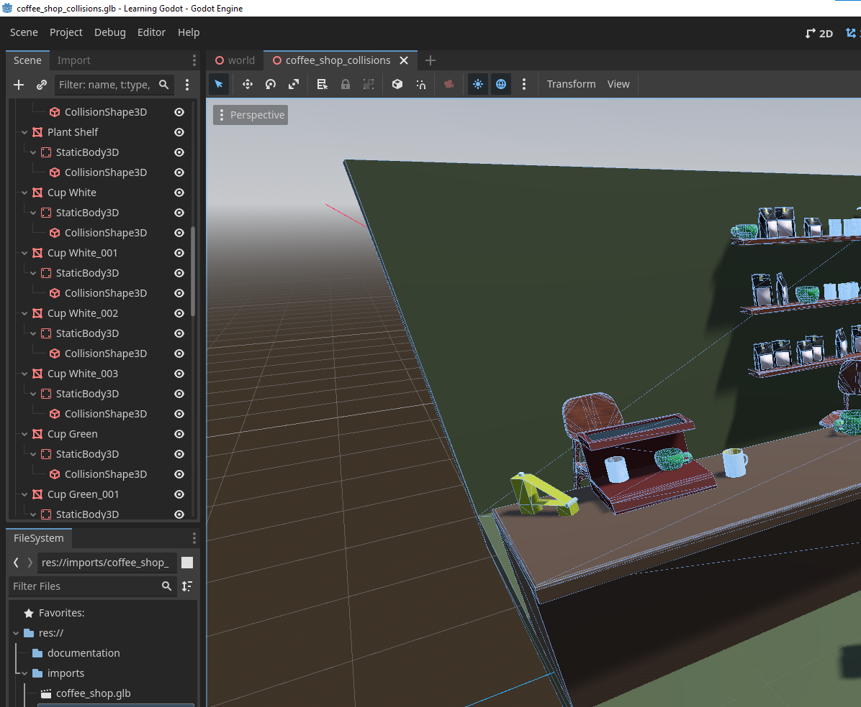  
I found a way to add accurate collisions to all the individual objects of the imported coffee shop. If you add -col to mesh name in Blender, the exported .glb file will have collisions set up for that object. Of course I could set collisions manually in Godot, but I just found that this way is much more efficient.

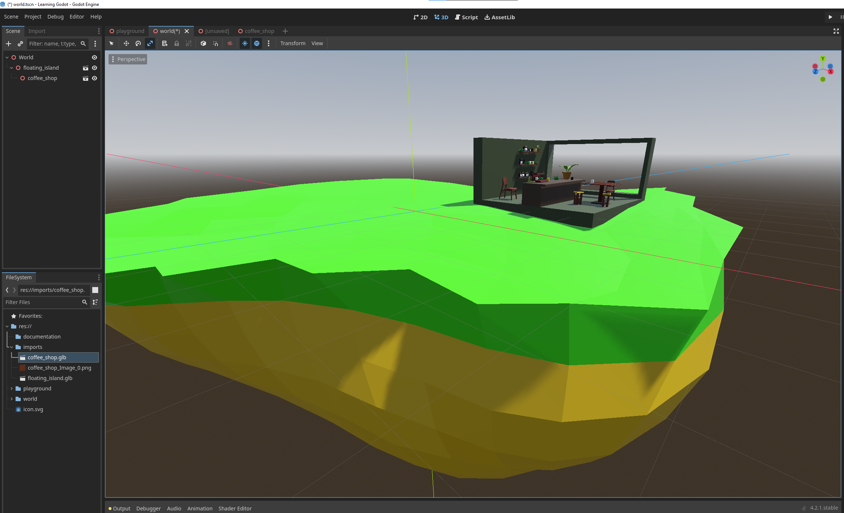  
Imported the island and the coffee shop into Godot.

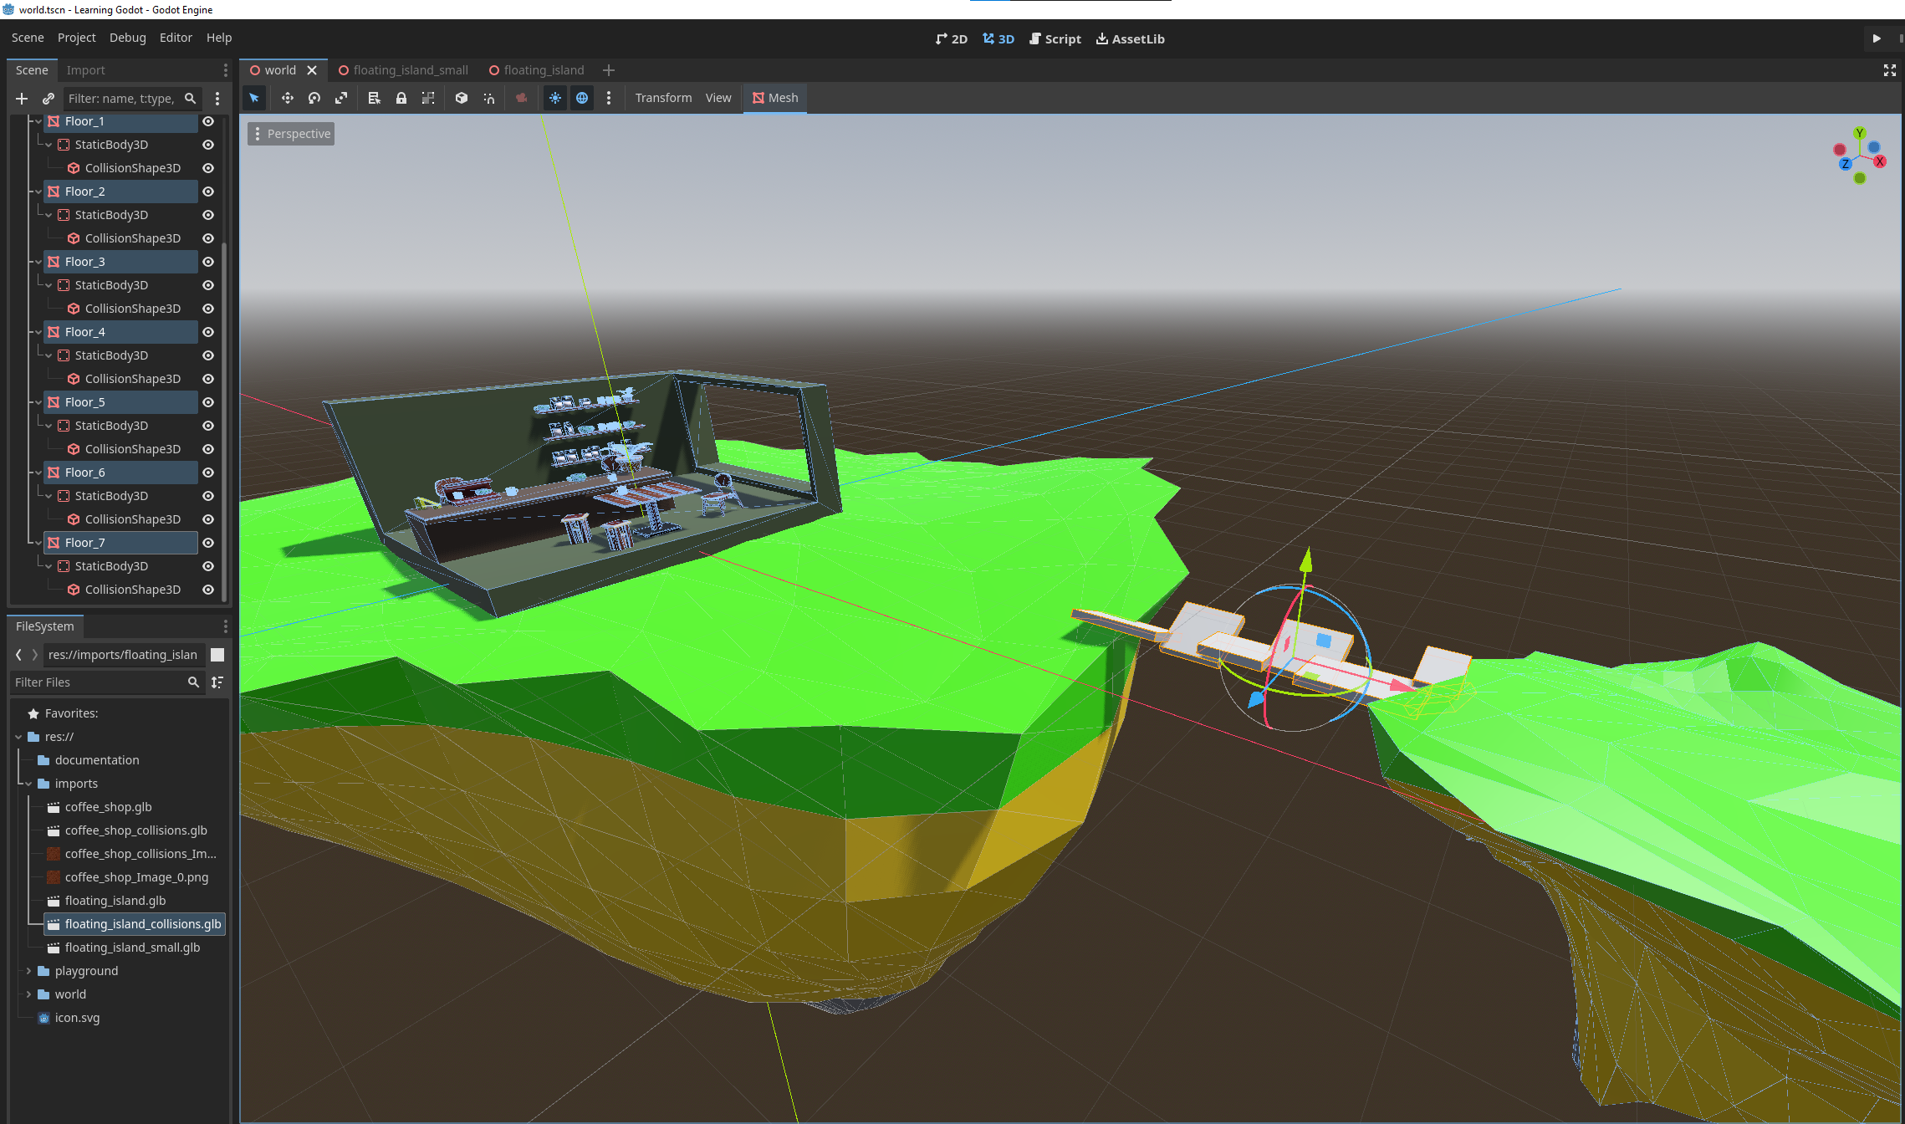  
Created a second island and connected it with a bridge.

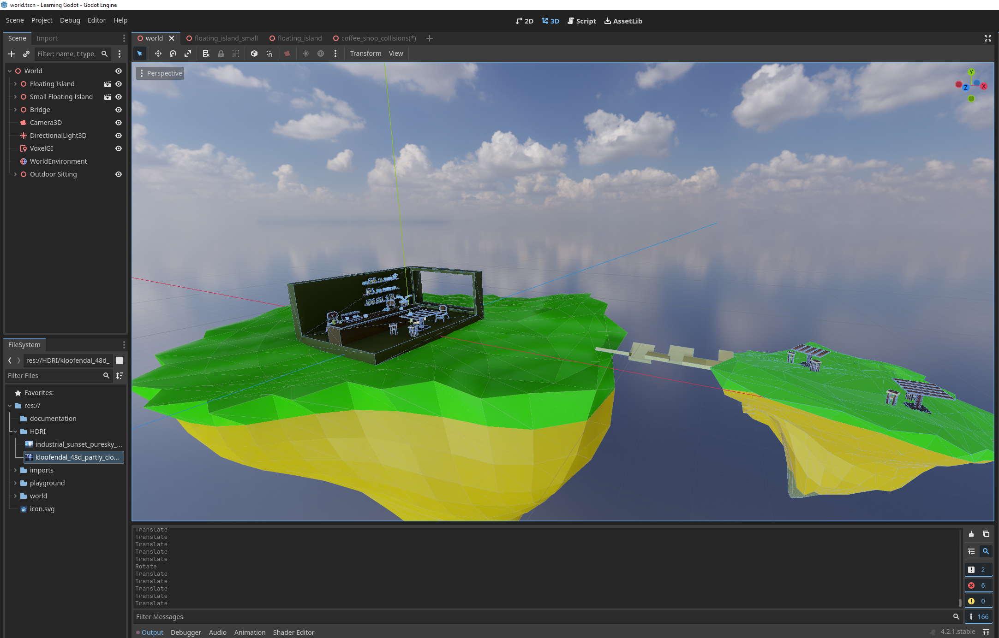  
Final scene of the floating islands with the coffee shop.

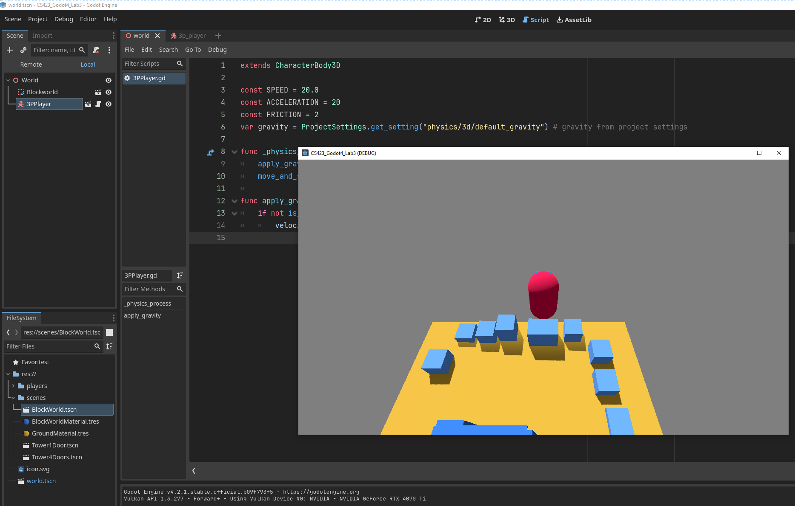  
Flying off to the space when changing velocity.y -= gravity \* delta to velocity.y += gravity \* delta.

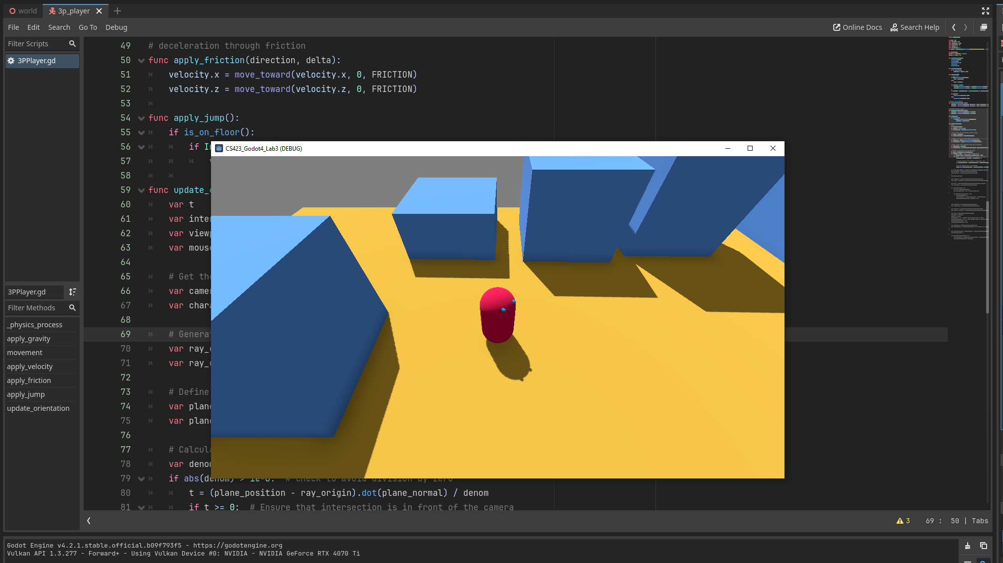  
Third person controller. The character is looking towards the mouse at all times.

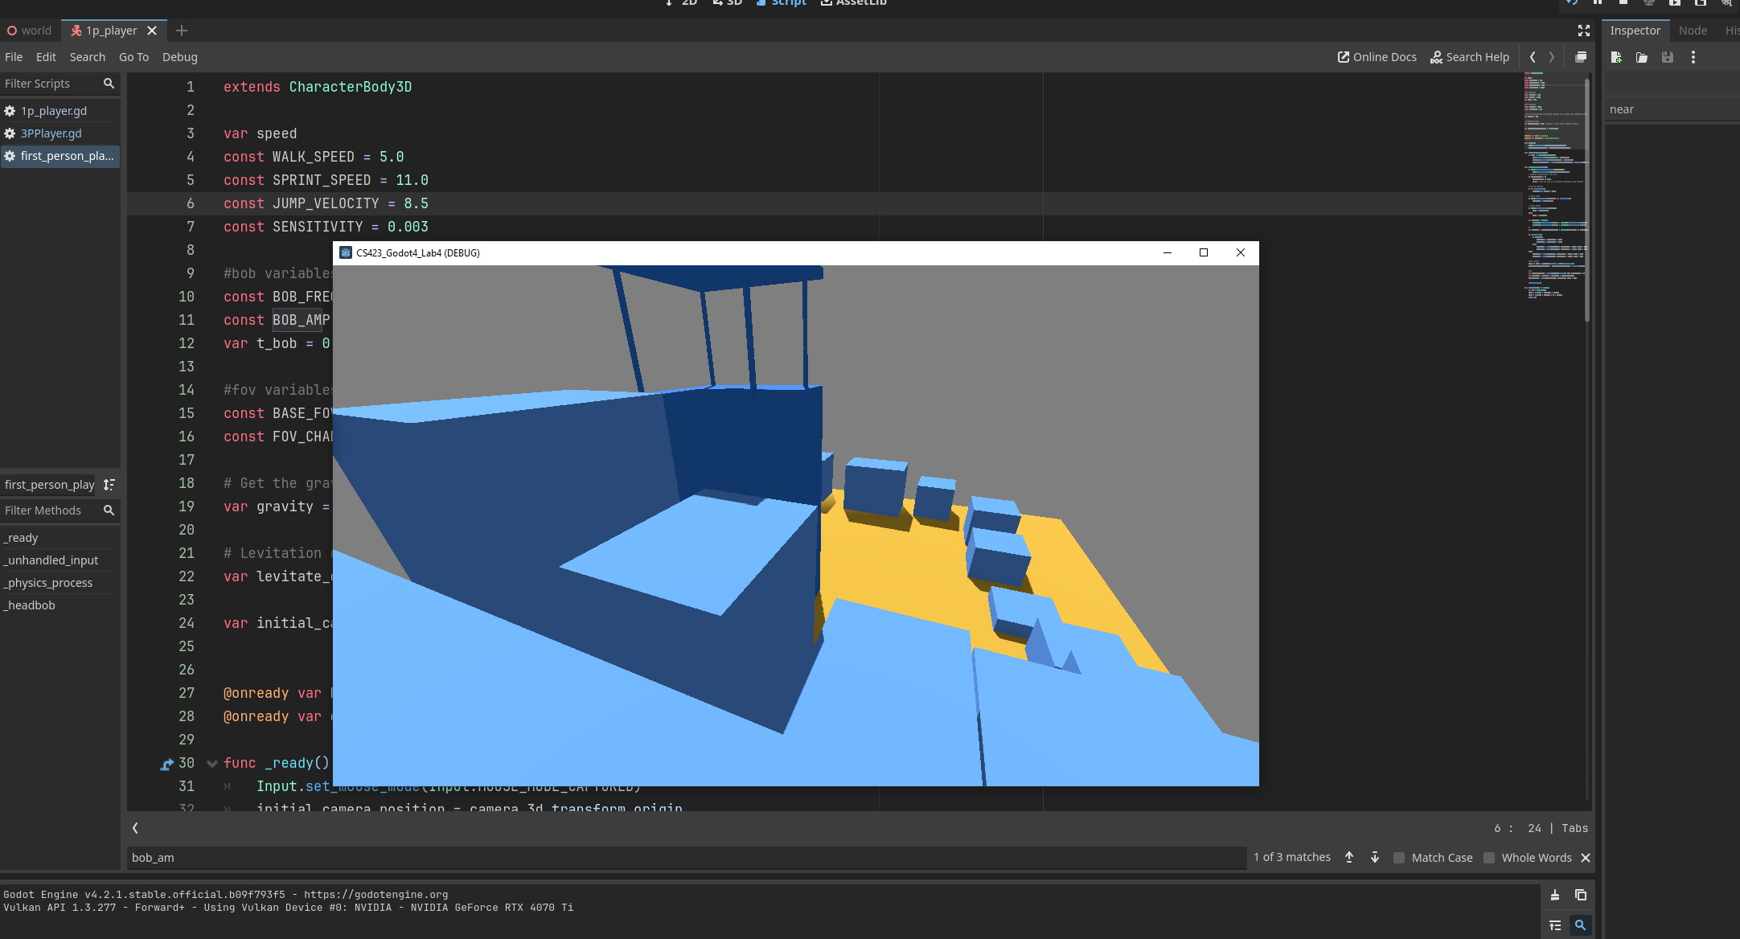  
First person controller reaching the top (almost)

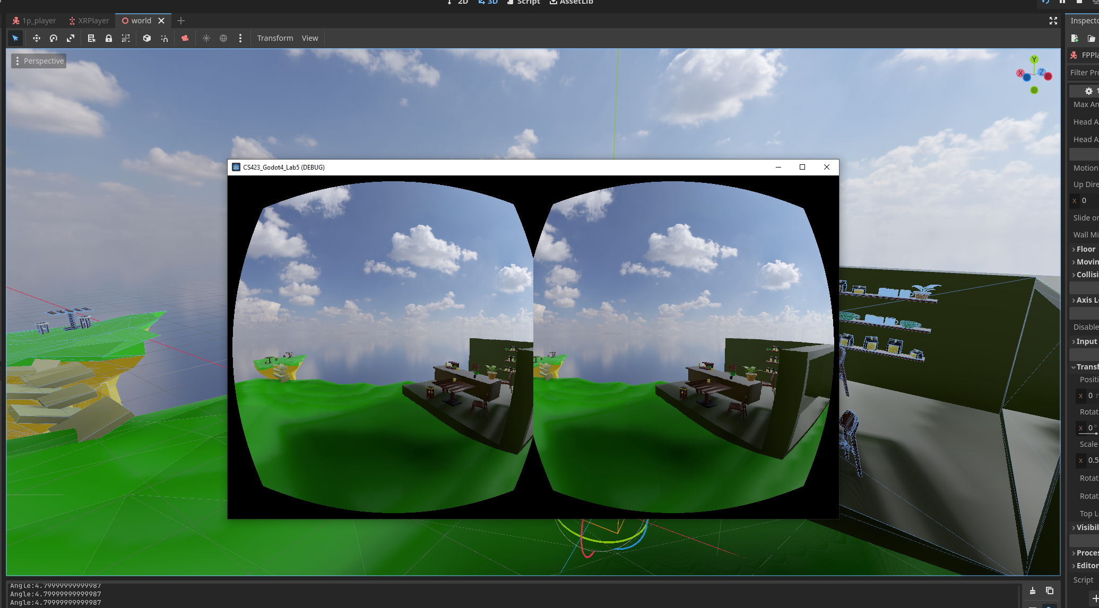  
XRPlayer controller in a floating island scene (works on android too).

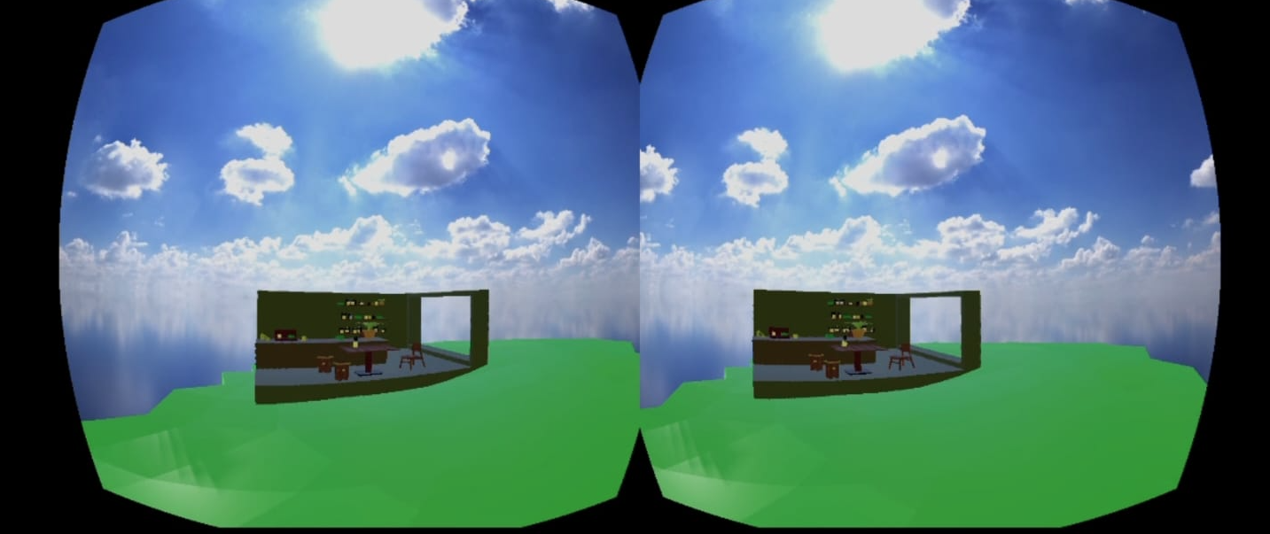  
Screenshot from Android phone after installing the .apk file and running the application. The controls work by tilting phone forward (move forward) and backward (move backward). Can also control the player by sliding fingers forward and backward.  
  
All of labs were save in my personal github and are public for your viewing:  
Lab 3 - <https://github.com/Ladnopoka/godot-playground>  
Lab 4 - <https://github.com/Ladnopoka/CS423_Godot4_Lab4>  
Lab 5 - <https://github.com/Ladnopoka/CS423_Godot4_Lab5>